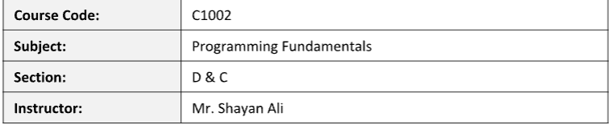
STUDENT SUBMISSION DETAILS
Name: Bhavishka kumari
Roll No / ID: 26k-3130
Class / Section: D
Date of Submission: 28-9-2026
TASK1
#include <stdio.h>
int main() {
float temperature;

printf("Enter the temperature in Celsius: ");
scanf("%f", &temperature);

if (temperature < 15) {
printf("Cold\n");
} else if (temperature >= 15 && temperature <= 30) {
printf("Normal\n");
} else {
printf("Hot\n");
}
return 0;
}
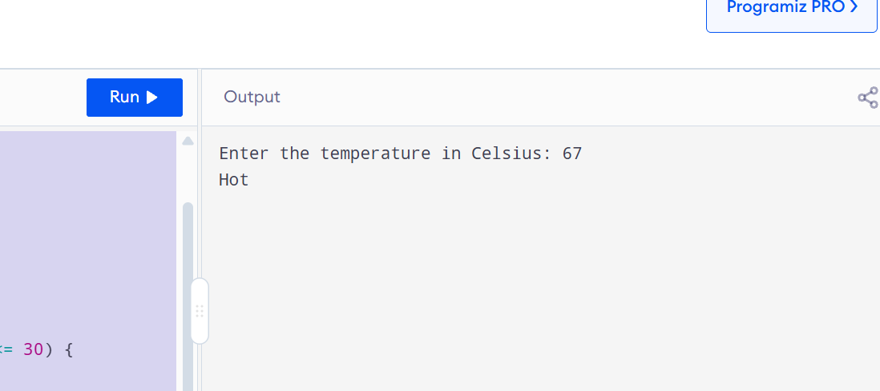

TASK2
#include <stdio.h>

int main() {
int balance;

printf("Enter remaining balance: ");
scanf("%d", &balance);

if (balance < 500) {
printf("Low Balance\n");
}
else if (balance >= 500 && balance <= 2000) {
printf("Sufficient Balance\n");
}
else {
printf("Premium Balance\n");
}

return 0;
}
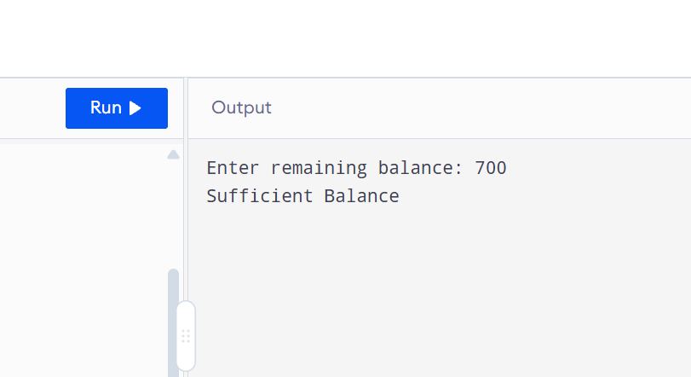

TASK3
#include<stdio.h>
int main() {
int appointment, doctorAvailable, registrationCompleted;

printf("Enter appointment (1 for yes, 0 for no): ");
scanf("%d", &appointment);

printf("Enter doctor availability (1 for yes, 0 for no): ");
scanf("%d", &doctorAvailable);

printf("Enter registration completion (1 for yes, 0 for no): ");
scanf("%d", &registrationCompleted);

if (appointment == 1) {
if (doctorAvailable == 1) {
if (registrationCompleted == 1) {
printf("The patient can meet the doctor.\n");
} else {
printf("The patient cannot meet the doctor: Registration is not completed.\n");
}
} else {
printf("The patient cannot meet the doctor: Doctor is not available.\n");
}
} else {
printf("The patient cannot meet the doctor: No appointment found.\n");
}

return 0;
}

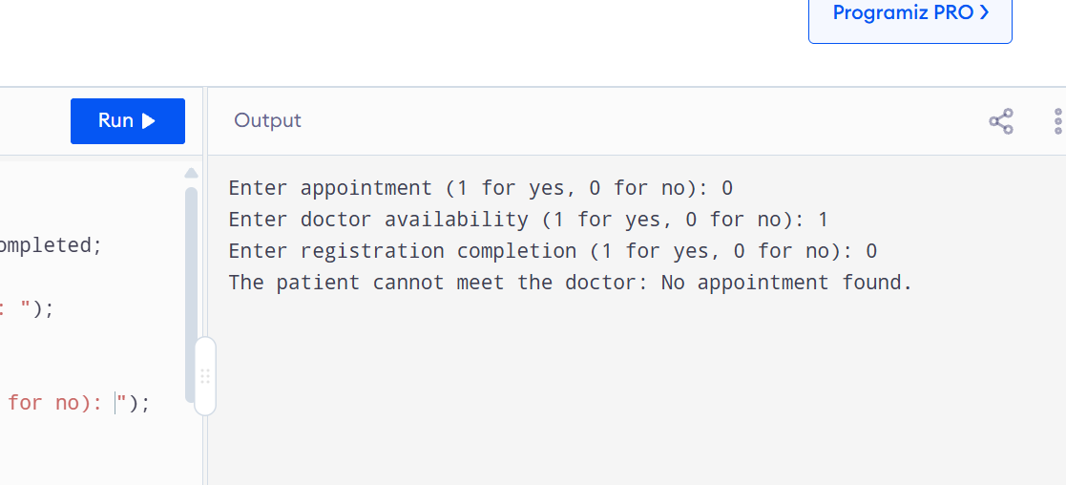

TASK4
#include <stdio.h>

int main() {
int restaurantOpen, itemAvailable, balanceSufficient;

printf("Enter restaurantOpen (1/0): ");
scanf("%d", &restaurantOpen);
printf("Enter itemAvailable (1/0): ");
scanf("%d", &itemAvailable);
printf("Enter balanceSufficient (1/0): ");
scanf("%d", &balanceSufficient);

if (restaurantOpen == 1) {
if (itemAvailable == 1) {
if (balanceSufficient == 1) {
printf("Order placed successfully!\n");
} else {
printf("Order failed: Insufficient balance.\n");
}
} else {
printf("Order failed: Item not available.\n");
}
} else {
printf("Order failed: Restaurant is closed.\n");
}

return 0;
}
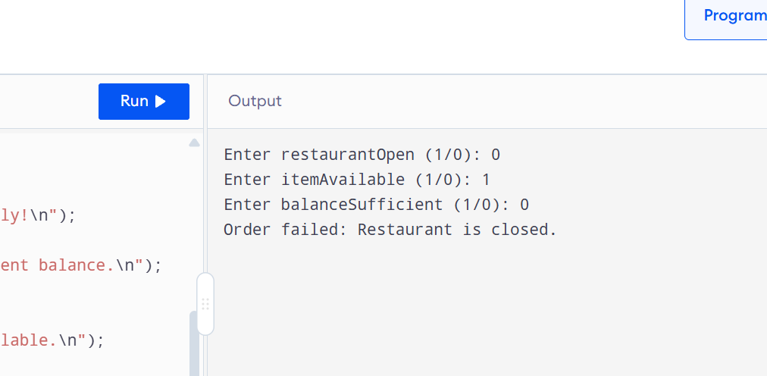

TASK5
#include <stdio.h>

int main() {
int operation, accountType;

printf("Enter operation (1: Balance Inquiry, 2: Cash Withdrawal, 3: Cash Deposit, 4: PIN Change): ");
scanf("%d", &operation);

printf("Enter account type (1: Savings Account, 2: Current Account): ");
scanf("%d", &accountType);

switch (operation) {
case 1:
printf("Selected Operation: Balance Inquiry\n");
switch (accountType) {
case 1:
printf("Account Type: Savings Account\n");
break;
case 2:
printf("Account Type: Current Account\n");
break;
default:
printf("Invalid Account Type\n");
}
break;
case 2:
printf("Selected Operation: Cash Withdrawal\n");
switch (accountType) {
case 1:
printf("Account Type: Savings Account\n");
break;
case 2:
printf("Account Type: Current Account\n");
break;
default:
printf("Invalid Account Type\n");
}
break;
case 3:
printf("Selected Operation: Cash Deposit\n");
switch (accountType) {
case 1:
printf("Account Type: Savings Account\n");
break;
case 2:
printf("Account Type: Current Account\n");
break;
default:
printf("Invalid Account Type\n");
}
break;
case 4:
printf("Selected Operation: PIN Change\n");
switch (accountType) {
case 1:
printf("Account Type: Savings Account\n");
break;
case 2:
printf("Account Type: Current Account\n");
break;
default:
printf("Invalid Account Type\n");
}
break;
default:
printf("Invalid Operation Choice\n");
}

return 0;
}
